Class 8

**Lecture**

**22**

**HTML**



**Lab Objectives:**

* div

# HTML Block and Inline Elements

Every HTML element has a default display value depending on what type of element it is. The default display value for most elements is block or inline.

# Block-level Elements

A block-level element always starts on a new line and takes up the full width available (stretches out to the left and right as far as it can).

The <div> element is a block-level element.

Example:

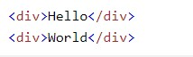

Try yourself

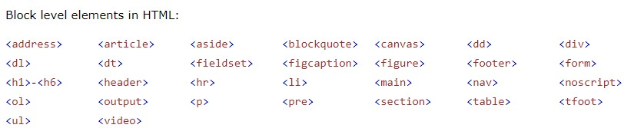 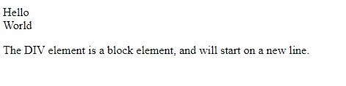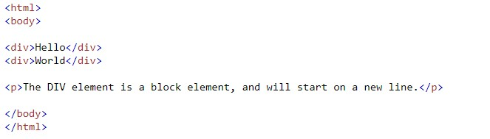Block Elements in HTML

# Inline Elements

An inline element does not start on a new line and only takes up as much width as necessary.

This is an inline <span> element inside a paragraph.

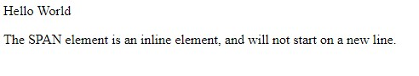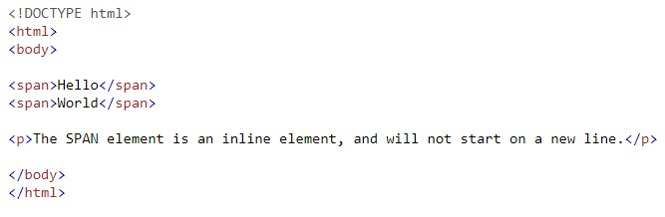

# Inline elements in HTML

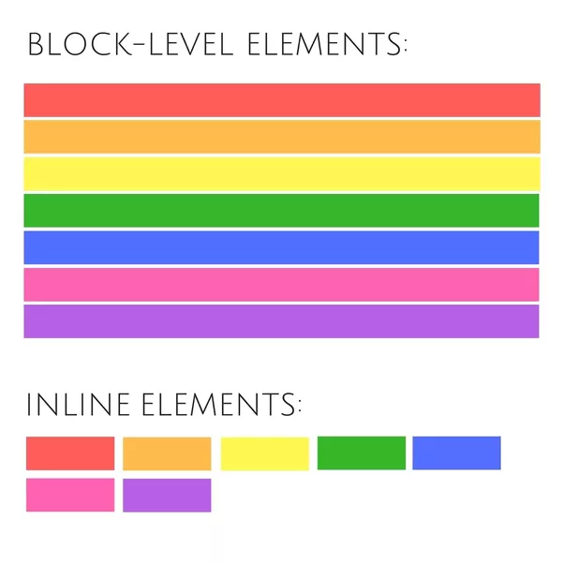

# The <div> Element

The <div> element is often used as a container for other HTML elements.

The <div> element has no required attributes, but style, class and id are common.

When used together with CSS, the <div> element can be used to style blocks of content:

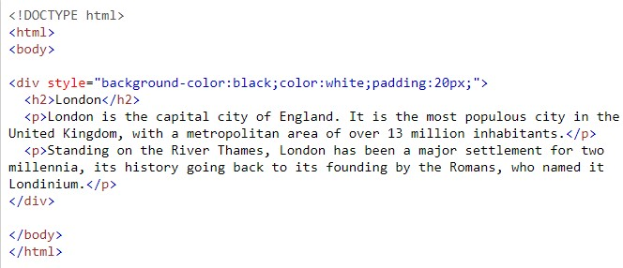

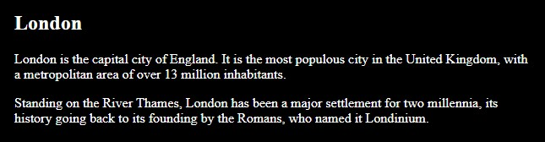

# HTML Grouping Tags

|  |  |
| --- | --- |
| Tag | Description |
| <div> | Defines a section in a document (block-level) |
| <span> | Defines a section in a document (inline) |

Try all the blocks element and inline elements by implementing in a text editor.